**CREATE NODE RED SERVICE**

|  |  |
| --- | --- |
| **TEAM ID** | PNT2022TMID29999 |
| **PROJECT NAME** | GAS LEAKAGE MONITORING AND ALERTING SYSTEM FOR INDUSTRIES |

**Step 1:**

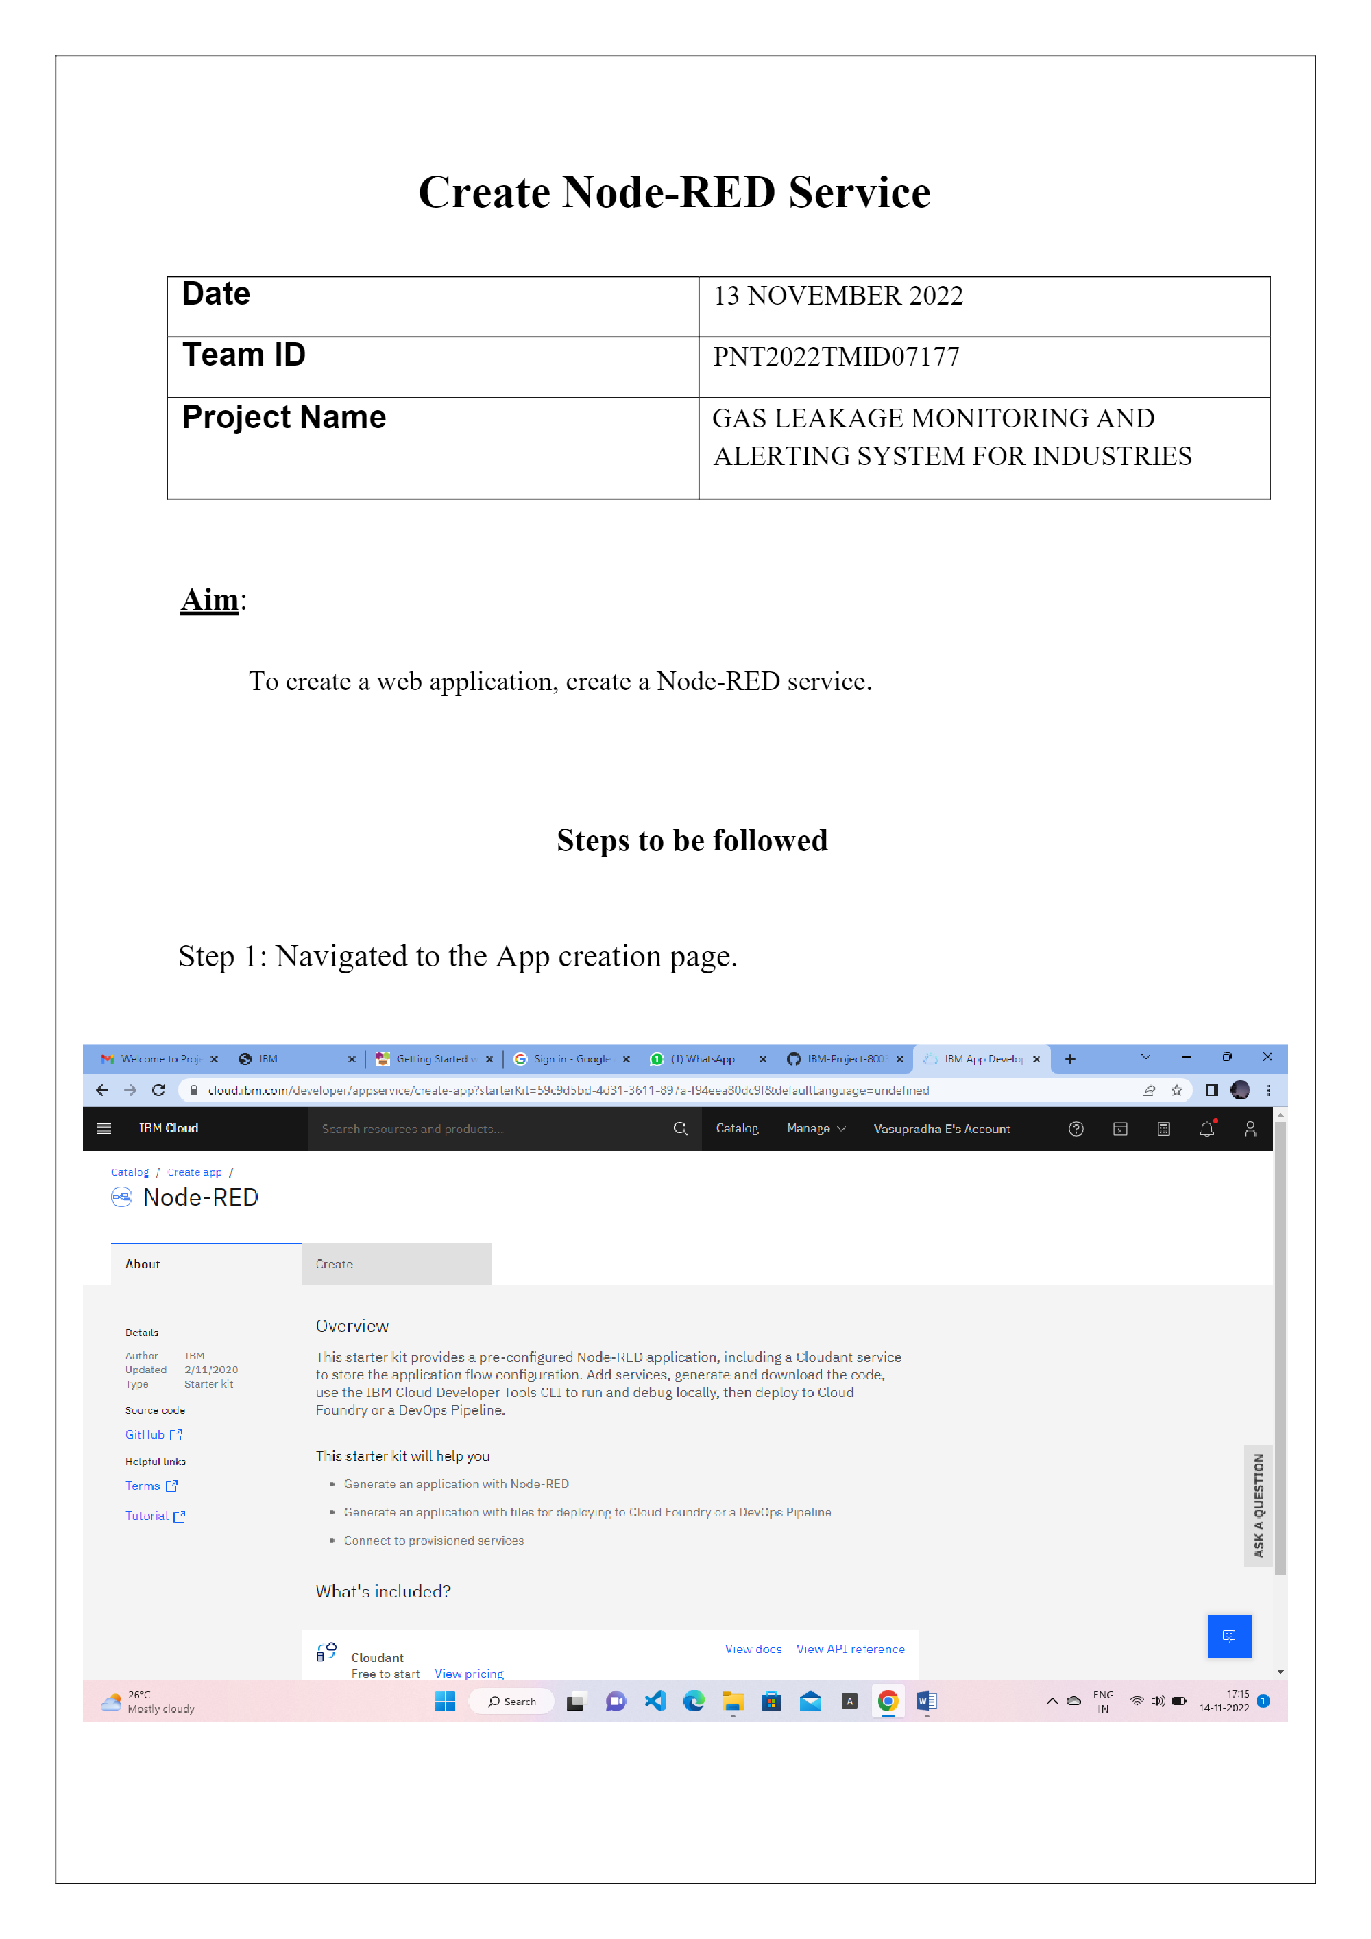

**STEP 2:**

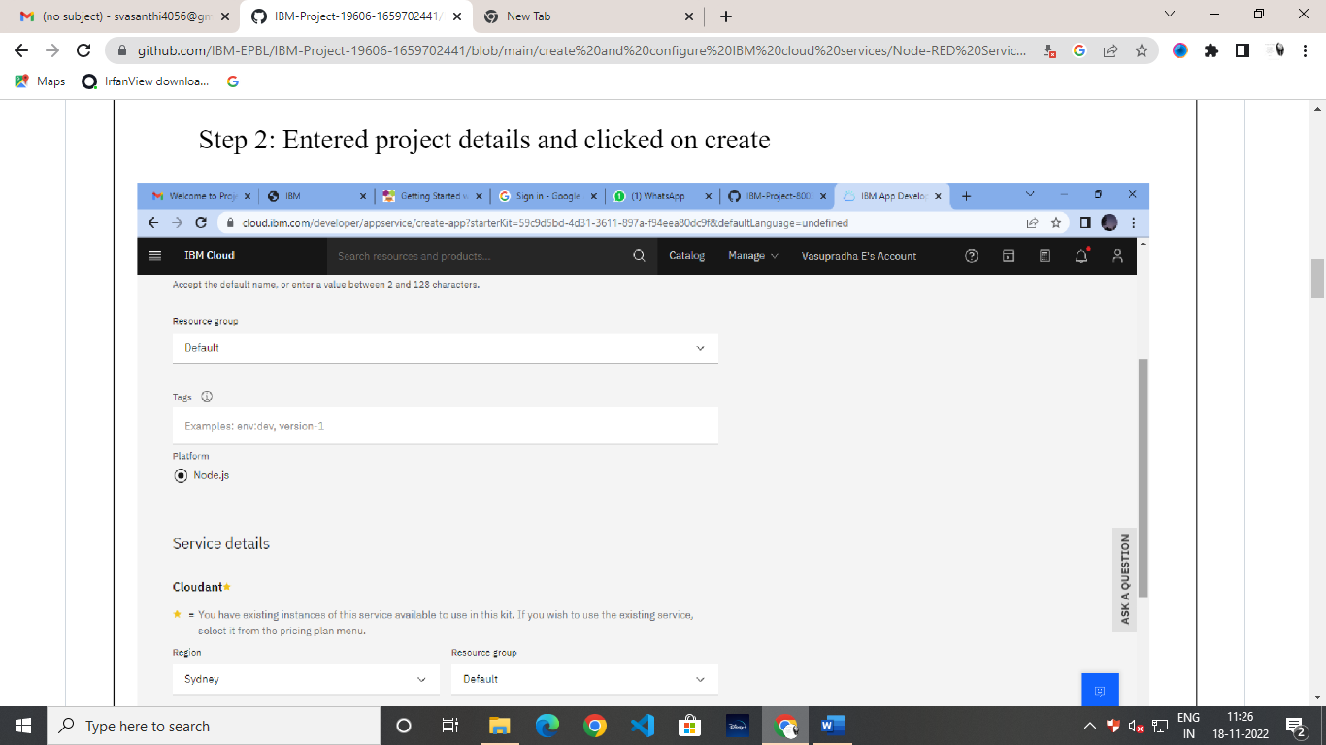

**STEP 3:**

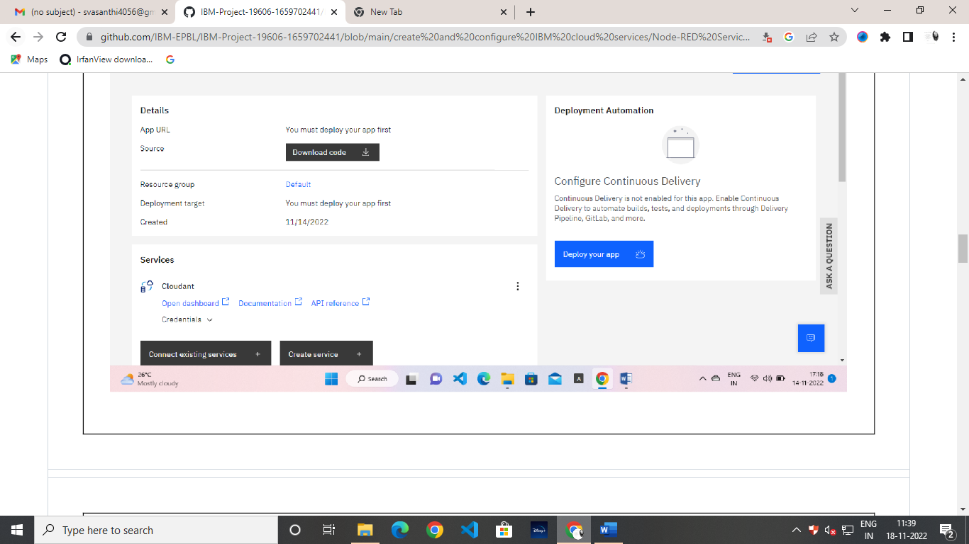

**Step 4:**

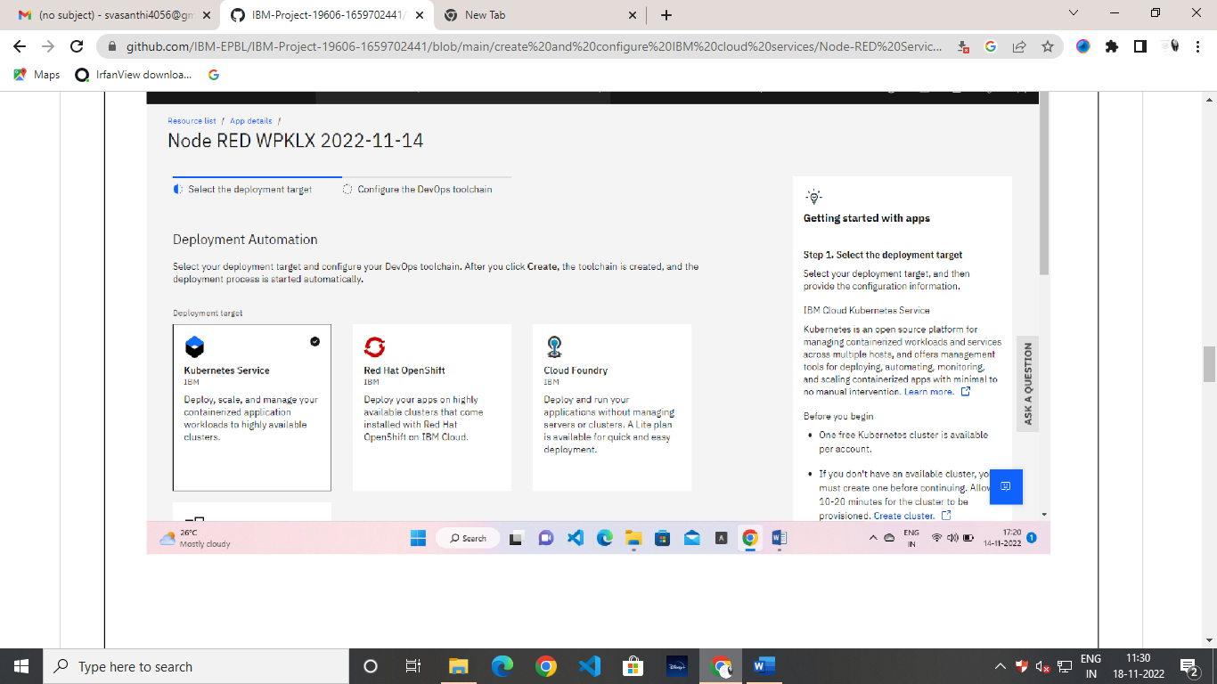

**Step 5:**

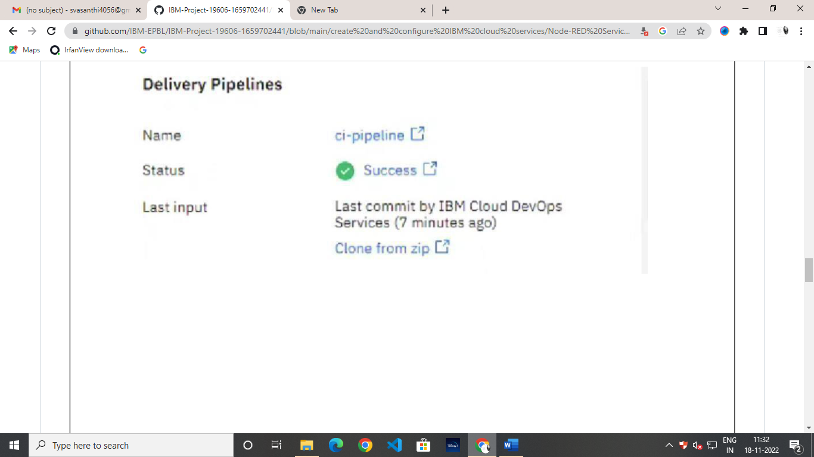

**Step 6:**

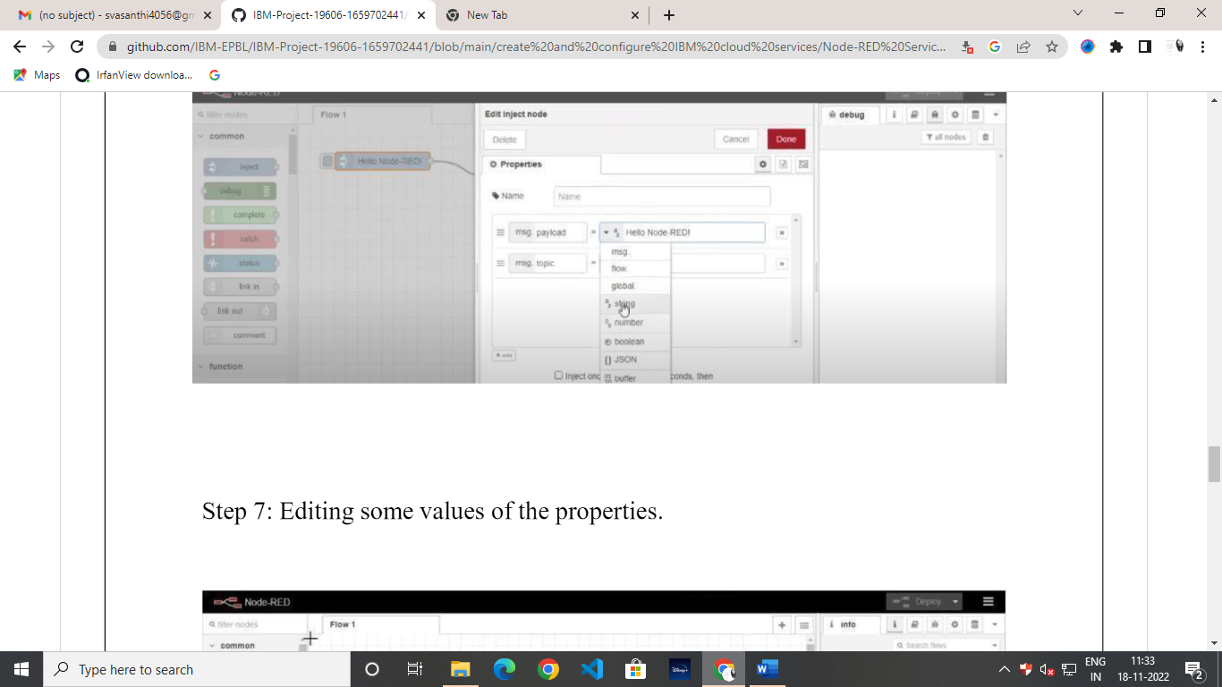

**Step 7:**

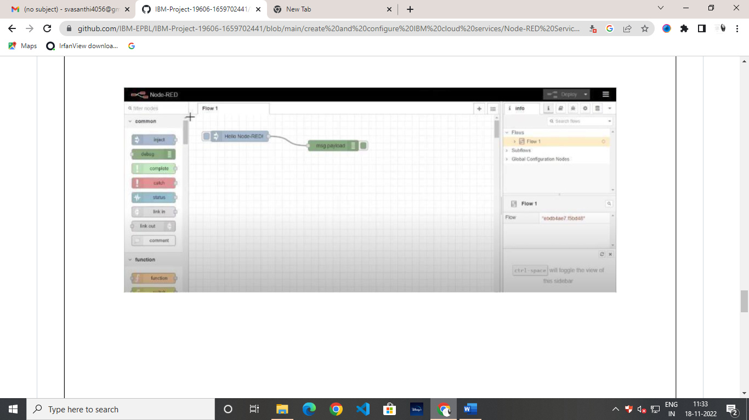

**Step 8:**

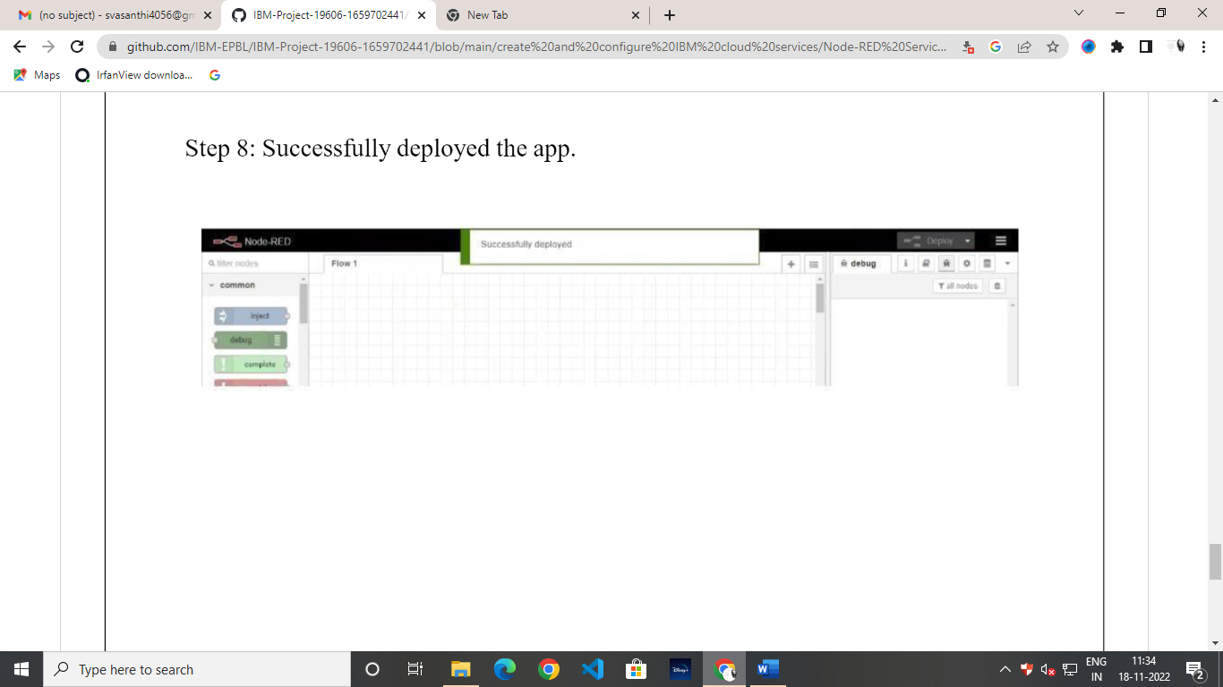

Successfully created a Node Red service on IBM Cloud